

*shell programming lab*

aSsignment -2

**SUBMITTED BY: SUBMITTED TO:**

**AYUSH KUMAR JHA Dr. Dhiviya Rose**

**SAP ID - 500086400**

**Enrollment no - R200220083**

**B.C.A -I.O.T.**

## **Assignment Content**

Top of Form

**EXPERIMENT – 2**

**TITLE:** Working with General Purpose Utility and File Commands

**Activities:**

A.Practice the following commands:

{ who, passwd,w,tty,lock,stty,script,clear,tput,uname,date,cal,calender,bc }

B.Practiceon the various File Attributes:

{ls, ls-l,ls –d, chmod, umask, chown, chgrp, touch, Change Permissions, ln, find }

Give the description of the command in a table format with execution screenshot.

1. who command is **a tool print information about users who are currently logged in**.Bottom of Form

who

who command is a tool print information about users who are currently logged in.

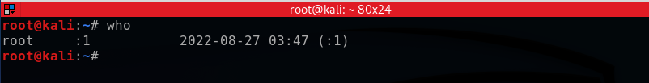

2.passwd

The passwd command changes passwords for user accounts.

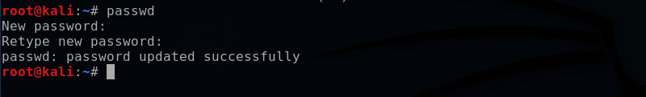

3. w

The w command is a built-in tool that allows administrators to view information about users that are currently logged in.

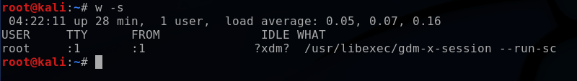

4.tty

The tty command of terminal basically prints the file name of the terminal connected to standard input.



5. stty

stty command in Linux is used to change and print terminal line settings. Basically, this command shows or changes terminal characteristics.

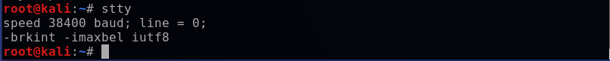

6. script

script command in Linux is used to make typescript or record all the terminal activities. After executing the script command it starts recording everything printed on the screen including the inputs and outputs until exit.

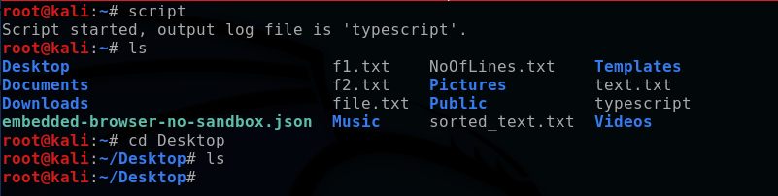

7. clear

clear is a standard Unix computer operating system command that is used to clear the terminal screen.

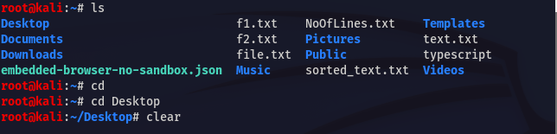

8.tput

tput command accepts the terminal commands and output the control code sequences for that terminal. Using tput you can control the color and cursor of your terminal.

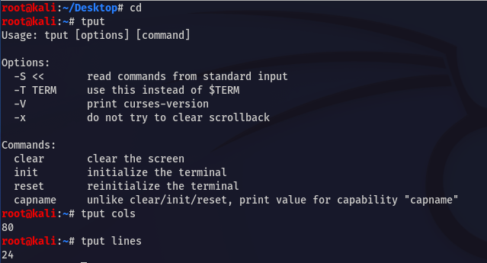

9.uname

To display system information, use the uname command.

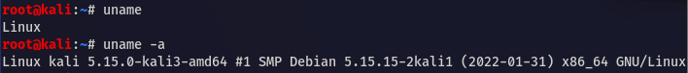

10. date

date command is used to display the system date and time.

11.cal

cal command is a calendar command in Linux which is used to see the calendar of a specific month or a whole year.

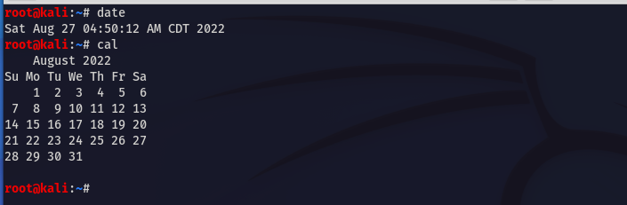

12.bc

bc (Basic Calculator) is a command line utility that offers everything you expect from a simple scientific or financial calculator.



13. ls

The ls command is used to list files or directories in Linux and other Unix-based operating systems.

14.ls-l

ls -l use a long listing format

15.ls –d

-d --directory

list directories themselves, not their contents

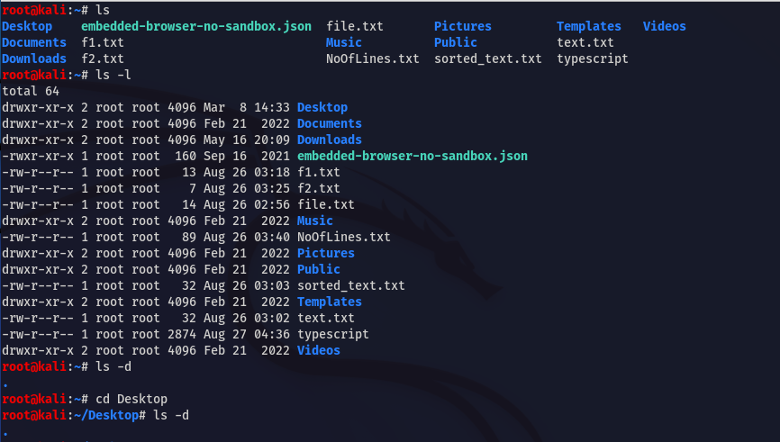

16.chmod

The chmod command is used to change the access mode of a file.

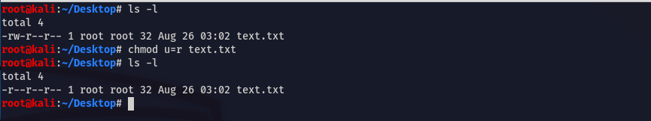

17.umask

The umask command in Linux is used to set default permissions for files or directories the user creates.



18.chown

The command chown, an abbreviation of change owner, is used on Unix and Unix-like operating systems to change the owner of file system files, directories.

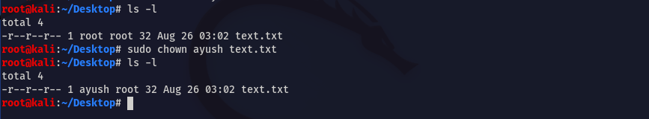

19.chgrp

chgrp command in Linux is used to change the group ownership of a file or directory. All files in Linux belong to an owner and a group.

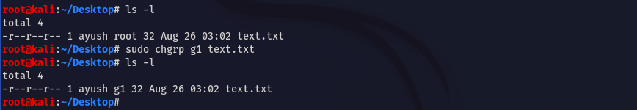

20.touch

The touch command's primary function is to modify a timestamp. Commonly, the utility is used for file creation.



21. Change Permissions



22.ln

The ln command is used to create **links** to files or directories.



23.find

Find is used to find files and directories and perform subsequent operations on them.

